D206 Task 1
D 206 Data Cleaning
Kiara A Ganger | 007775841
Western Governor University

Table of Contents
Part I: Research Question and Variables 5
A. The Question: 5
B. The Variables: 5
Part II: Data Cleaning Plan 5
C. Explanation of the plan: 5
C.1. Detection: 5
C.2. Why? – 6
C.3. What Programming Language? 7
C.4. Detection Code: 7
Part III: Data Cleaning Treatment 11
D. Summarized data cleaning process: 11
D.1. What did I find? 11
D.2. How did you treat it? Why did you treat it that way? 11
D.3. Summarize your work: 13
D.4. The Treatment Code: 14
D.5. Treatment code file 17
D.6. Disadvantages: 18
D.7. Challenges: 18
Part IV: PCA 19
E. Perform PCV 19
E.1. List of Quantitative Continuous Variables 19
E.2. Which PCs should be retained and why? 19
E.3. Benefit from the results of the PCA 19
F. Panopto recording: 20
G. Third-Party Code References 20
H. References 20
Tables and Figures of Untreated Data D.1 21
Table 1 21
Table 2 24
Table 3 24
Table 5 24
Figure: 1 25
Figure: 2 25
Figure: 3 25
Figure: 4 25
Figure: 5 25
Figure: 6 25
Figure: 7 25
Figure: 8 25
Figure: 9 26
Figure: 10 26
Figure: 11 26
Figure: 12 26
Figure: 13 26
Figure: 14 26
Figure: 15 26
Figure: 16 26
Figure: 17 27
Figure: 19. 27
Figure 20 28
Figure 21 29

Part I: Research Question and Variables
- The Question:
What factors influence customer turnover?
- The Variables:
The variables of this data set are described in the table below. First, I need to upload the churn file by clicking the import button and making sure to check it has headers as shown in Figure 1.. There are a total of 52 variables in this set. To gather the description of each variable I will be using R. By running the str() command R gives me the name of the variable, data type in programing (e.g. integer, float, char, etc.). To get the Scales data type (e.g. qualitative, quantitative) I referenced to the Scales chart (Eric Straw, Ph.D. , 2023).

Part II: Data Cleaning Plan
- Explanation of the plan:
  - Detection:
In this section, I will discuss the techniques I used to uncover the data quality issues:

Duplicates:
To detect duplicates in the dataset I plan to use the sum(duplicated()) function. This will return the rows marked as true if it has duplicates. Then I will use the sum(duplicated(churn)) to get the total count of duplicated values. If there are any duplicated values, I will remove them or merge them depending on what is needed.

Missing Values:
By using the colSums(is.na(churn)) and the sum(is.na(churn)) function, I will calculate the count of missing values for each column. Then, I will calculate the percentage of missing values for each column by dividing the missing count by the total number of observations in the dataset using (missing_per_column / total_number_observations) * 100. This will give me a better understanding of the extent of missingness in each column relative to the entire dataset. I will also visualize missing values using geom_histogram, geom_bar and theme_minimal. to gain insights into their distribution.

Outliers:
To identify outliers in the dataset, I will be using the find_outliers <- function(data, column_name) {z_scores <- scale(data[[column_name]]) return(data[abs(z_scores) > 3, column_name])} function. To get the number of outliers, min and max values I will use the cat() function. To narrow it down to the Columns I need I use the outliers_column_name <- find_outliers(churn, 'Column_name') To visualize the distribution of the data I will be using boxplot(churn$variable_name, main = "Boxplot of Variable").

Re-expression of categorical variables and other data quality issues:
I will identify any inconsistencies such as different spellings or variations of the same category. By using functions like unique(), I can extract unique values from the categorical variables. Using tolower() or toupper() I will standardize or recode categories to address any inconsistencies. For miss spellings gsub() or stringr::str_replace().
For Other data quality issues like Renaming columns that don’t have a clear or meaningful name I plan to use the colnames() function.
  - Why? –
In this section, I will explain why I chose the specific functions and commands to uncover the following data quality issues within the dataset:

Duplicates:
I am using the functions chosen in C.1. because the sum(duplicated()) function, will give me a total count of the duplicated values. I will need this information to better understand how often duplicated records occur.

Missing Values:
I am using the colSums(is.na(churn)) and the sum(is.na(churn)) function to identify missing values, because it presents them in a tabular format for an easy assessment. The (missing_per_column / total_number_observations) * 100 will give me the percentage of missing information for each column, which will let know if I am able to just remove the rows. To visualize missing data, I used the ggplot function geom_histogram, geom_bar and to create histograms and bar graph, because this allows me to observe the frequency distribution of the data and theme_minimal because I can set the title of the plot to 'Histogram of column_name' and adjusted the appearance providing me insights into their distribution.

Outliers:
I am using these functions because looking at how variables are spread out with a box plot boxplot(churn$variable_name, main = "Boxplot of Variable") helps me see if the data is acting normal. This will give me a chance at spotting outliers accurately. Naming the code to find the outliers in ‘find_outliers’ helps to clearly communicate its use. By using the z-scores scale() function it scales the dataset to have a mean of 0 and a standard deviation of 1, allowing me to easily identify extreme values.

Re-expression of categorical variables and other data quality issues:
Ensuring consistency in categorical variable representation is important. I used unique() to extract unique values, identifying inconsistencies like different spellings or variations of the same category. And functions like tolower() or toupper() to convert all entries to lowercase or uppercase, and then using gsub() or stringr::str_replace() to correct misspellings.
I’m using colnames() function because, clear column names can also make it easier to write code and perform operations on the dataset
  - What Programming Language?
For this task, I chose to use the R programming language. I found R to be more user-friendly and aligned with my learning style. The syntax of R was easier for me to understand, and the overall setup process was simpler compared to Python.
Libraries and Packages:
I installed the tidyverse package in R, which includes essential libraries such as dplyr, tidyr, and ggplot2. These libraries provided me with the necessary functions to efficiently work with the dataset and perform various data manipulation tasks. dplyr and tidyr facilitated data cleaning and reshaping operations, while ggplot2 allowed me to create informative visualizations for exploratory data analysis.
  - Detection Code:
See code attached. Filename: data_quality_detection_kg.R

Packages and Libraries:
# Install the tidyverse package
install.packages("tidyverse")

#Load the libraries
library(tidyverse)
library(ggplot2)

#Import the churn data
churn <-
read.csv("C:/Users/kiara/OneDrive/WGU MSDA/D206/churn_raw_data.csv")
View(churn)

# #Getting to know the DATA
Summary(churn)

Duplicates:
# Detecting Duplicates
duplicates <- duplicated(churn)
duplicate_count <- sum(duplicates)
#Print the results
print(duplicate_count)

Missing Values:
# Total number of observations (rows) in the dataset
total_rows <- nrow(churn)
# Total number of columns in the dataset
total_columns <- ncol(churn)
# Total number of values in the dataset, including Nas
total_values <- total_rows * total_columns
# Print the total number of values
print(total_values)

# Detecting Missing Values Percentage for the dataset as a whole
# Sum of missing values across all columns
total_missing <- sum(is.na(churn))
# Percentage of missing values in the entire dataset
missing_percentage <-
(total_missing / (total_rows * ncol(churn))) * 100
# Print the missing percentage
print(missing_percentage)

# Breaking it down per column
# Missing count per columns
missing_per_column <- colSums(is.na(churn))
# Print results
print(missing_per_column)

# Missing percentage per columns
missing_percentage_per_column <- (missing_per_column / total_rows) * 100
# Print results
print(missing_percentage_per_column)

#finding the distribution of the Variables using a Histogram
# Specifing the columns with the missing values
columns_of_interest <-
c("Children", "Age", "Income", "Tenure", "Bandwidth_GB_Year”)

# Create histograms for each specified column
for (col in columns_of_interest) {
# Create histogram including missing values
c <- ggplot(churn, aes(x = .data[[col]])) +
geom_histogram(fill = "skyblue", color = "black") +
labs(title = paste("Histogram of", col),
x = col,
y = "Frequency") +
theme_minimal() +
theme(plot.title = element_text(hjust = 0.5))
# Print the histogram
print(c)
}
# Create histogram-like plot for the Techie column using counts
t <- ggplot(churn, aes(x = Techie)) +
geom_bar(fill = "skyblue",
color = "black",
na.rm = TRUE) + # Exclude missing values
labs(title = "Bar Plot of Techie",
x = "Techie", y = "Count") +
theme_minimal() +
theme(plot.title = element_text(hjust = 0.5))
# Print the plot
print(t)
}
# Create histogram-like plot for the Phone column using counts
p <- ggplot(churn, aes(x = Phone)) +
geom_bar(fill = "skyblue",
color = "black",
na.rm = TRUE) + # Exclude missing values
labs(title = "Bar Plot of Phone",
x = "Phone", y = "Count") +
theme_minimal() +
theme(plot.title = element_text(hjust = 0.5))
# Print the histogram
print(p)
# Create histogram-like plot for the TechSupport column using counts
s <- ggplot(churn, aes(x = TechSupport)) +
geom_bar(fill = "skyblue",
color = "black",
na.rm = TRUE) + # Exclude missing values
labs(title = "Bar Plot of TechSupport",
x = "TechSupport", y = "Count") +
theme_minimal() +
theme(plot.title = element_text(hjust = 0.5))
# Print the histogram
print(s)

Outliers:
#Finding the Outliers (Soetewey, 2020)
#Finding the Outliers
# Define the quantitative columns of interest
quantitative_columns <-
c(
"Tenure",
"Children",
"Income",
"Age",
"Bandwidth_GB_Year",
"Population",
"Email",
"Contacts",
"Outage_sec_perweek",
"MonthlyCharge",
"Yearly_equip_failure"
)

# Create boxplots for each quantitative column
par(mfrow = c(4, 3)) # Set up a multi-panel plot
for (col in quantitative_columns) {
boxplot(
churn[[col]],
main = col,
ylab = "Value",
col = "skyblue",
border = "black"
)
}
# Reset the plotting settings
par(mfrow = c(1, 1))

Other Data Quality Issues:
No code used to detect.

Part III: Data Cleaning Treatment
- Summarized data cleaning process:
  - What did I find?

Duplicates:
I found no duplicates in this data set.

Missing Values:
I found that the dataset has 10,000 rolls.520000 values in total and 13906 of those are N/A. Telling me that 2.67% of the data is N/A. Please refer to Table2 for missing count per column and the percentage of missing values per column. I also found the distribution of the columns with missing values which provided the distribution of the data which will allow me to treat them. Figure 2, Figure 3 and Figure 4 are categorical variables. Figure 7 and Figure 9 have a skewed distribution: positively skewed. Figure 5 has a uniform distribution: equally spread, and Figure 6 and Figure 8 are bimodal distribution: two modes non-symmetric.
I also discovered that the Population and Outage_sec_perweek had what is called a hidden missing value. Data that is missing but labeled as something else. In this case instead of the value being NA it was put in as 0 or it’s a negative value. Which isn’t correct given that the customer will at lest given it a value of 1 including the number of Children they stated on the data and the outage can’t be negative.

Outliers:
After running the code inspired by Stats and R (Soetewey, 2020). I was able to see the Outliers of all the qualitative values shown in Figure 19.

Other Data Quality Issues:
The Item 1, Item 2 etc. columns were not clearly defined. The Age column had ages displaying as decimals, the Zip column had all zip codes from Puerto Rico showing up a 3 to 4-digit numbers because they start with 0s.
  - How did you treat it? Why did you treat it that way?

Duplicates:
Since there were no duplicates, there was nothing to treat.

Missing Values:
For the ‘Population’ column I checked the percentage of values that were entered as 0 and used the Removal method since it was only .98% of the total value in the column. I did the same for the ‘Outage_sec_perweek’ where the values were in the neg. I applied imputation techniques to manage missing values. For example, I replaced missing values in the "Children" column with the median value, in the ‘Age’ column with the mean value, in the "Techie" column with the mode value, etc.

Outliers:
I used Imputation columns:
- Email – which only 12 outliers imputation made the most logical sense.
- Population – For this one I used Imputation because the populations seem either too high or too low are a city. Some areas have only a population of 2 while others have the population of a state as a whole. Here I input all the values that were above the max whisker, turned them to Nas and then imputed them will the median value.
I used Exclusion for columns:
- Yearly_equip_failure
- Outage_sec_perweek
- Children
- Contacts
Exclusion seemed like the best option because I couldn’t find a sensible reason to remove them. Equipment failure could be several things including user error. Children count per family can range dramatically based on income, religion, and culture. Outage time can be affected by where you live and the number of times a customer can range on the situation.
I retained the following columns:
- MonthlyCharge- Because a person’s bill can vary depending on service. And it only 3 that are not far from the whisker.
- Income – I retained most of the Income except for the values above 130k since by looking at the boxplot everything above that was scarce.

Other data quality issues:
Here I renamed the columns name Item1, Item2 etc. I rounded the Age column down to whole numbers and added 0s to the beginning of the zip codes that were not complete to give them the required 5 digits.
  - Summarize your work:
The cleaning steps I took can be broken down into the following steps. After downloading the dataset into R Studios, I ran the summary() function to get a quick overview of what I was dealing with. Then I ran the duplicate function and confirmed that the dataset had no duplicates, so I was able to get cleaning by first taking care of those “hidden-missing” values. For this step I found the percentage of the values in Population that were marked as 0 and Outage_sec_perweek for the values that were in the negatives. Once I verified that they were under 1%, I dropped them. Then I got a count and percentage of the missing values for all columns. I then ran code to create histograms of each column with missing DATA so that I can find the distribution of the list. Once I found that out, I proceeded by converting all the null n/a values with either the mean, median or mode depending on the distribution of the histogram in a process called imputation. Then verifying that the imputations didn’t drastically change the distribution of the columns. I finished this step by running another count to make sure all n/as were cleared and processed to find the outliers.
To find the outliers I ran code to print a visual of all the quantitative columns as boxplots shown in Figure 19. Here I was able to point out which columns had outliers and focus solely on them Figure 20. After viewing the list of the outlier_columns I ran code to view them one by one. I used the Imputation method for Email and Population. Exclusion for Children, Contacts, Year_equip_failure, part of Income, and Outage_sec_perweek. For MonthlyCharge and the values under 130k in Income I used retention. Once I was happy with the way the boxplots look Figure 21. I concluded by renaming the Survey columns.
Here I ran code to change each name on the columns between item1 and item8. While trying to figure this step out, I discovered that I needed to load the library(magrittr). Llibrary(magrittr) is a package in R that provides a set of operators to make your code more readable and expressive. Then I gave them a clear and meaningful name so that the dataset is easier to understand and go through. Since the Age column had people’s ages as a decimal, I used the floor function to round them down to the nearest number. “There are several states in the US that have zip codes starting with 0. These states include Alaska (AK), Connecticut (CT), Massachusetts (MA), Maine (ME), New Hampshire (NH), New Jersey (NJ), Puerto Rico (PR), Rhode Island (RI), Vermont (VT), Virgin Islands (VI), APO Europe (AE), and FPO Europe (AE)” (Sanford, 27). For these Zip I had to run the sprintf() function to add the missing zeros to the beginning of the zip code and complete the entry.
  - The Treatment Code:
See code attached. Filename: data_treatment_kg.R

Duplicates:
#There were no duplicates to treat

Missing Values:
#treating missing values and hidden missing values
# Check summary statistics of the population column
summary(churn$Population)
# Check the number of rows before and after removal
print(paste("Number of rows before removal:", nrow(churn)))
# Remove rows where population is 0
churn <- subset(churn, Population != 0)
# Check the number of rows after removal
print(paste("Number of rows after removal:", nrow(churn)))

# Check the number of rows before removal
print(paste("Number of rows before removal:", nrow(churn)))
# Remove rows where Outage_sec_perweek is negative
churn <- subset(churn, Outage_sec_perweek >= 0)
# Check the number of rows after removal
print(paste("Number of rows after removal:", nrow(churn)))

#Finding the Mean, Median and Mode
# Imputation Type: Mean for Age column
mean_value <- mean(churn$Age, na.rm = TRUE)
churn$Age[is.na(churn$Age)] <- mean_value

# Function for median
median_impute <- function(data, column_name) {
median_value <- median(data[[column_name]], na.rm = TRUE)
data[[column_name]][is.na(data[[column_name]])] <- median_value
return(data)
}
# Function for mode
get_mode <- function(x) {
ux <- unique(x)
mode <- ux[which.max(tabulate(match(x, ux)))]
return(mode)
}
mode_impute <- function(data, column_name) {
mode_value <- get_mode(data[[column_name]])
data[[column_name]][is.na(data[[column_name]])] <- mode_value
return(data)
}
# Apply median imputation for multiple columns
columns_to_impute <-
c("Children", "Income", "Tenure", "Bandwidth_GB_Year")
for (col in columns_to_impute) {
churn <- median_impute(churn, col)
}
# Apply mode imputation for multiple columns
columns_to_impute <-
c("Techie", "Phone", "TechSupport")
for (col in columns_to_impute) {
churn <- mode_impute(churn, col)
}
#Verify the N/As are taken care of
# Print out the count of NAs for each of the 8 columns
cat("Count of NAs in Children: ", sum(is.na(churn$Children)), "\n")
cat("Count of NAs in Age: ", sum(is.na(churn$Age)), "\n")
cat("Count of NAs in Income: ", sum(is.na(churn$Income)), "\n")
cat("Count of NAs in Techie: ", sum(is.na(churn$Techie)), "\n")
cat("Count of NAs in Phone: ", sum(is.na(churn$Phone)), "\n")
cat("Count of NAs in TechSupport: ", sum(is.na(churn$TechSupport)), "\n")
cat("Count of NAs in Tenure: ", sum(is.na(churn$Tenure)), "\n")
cat("Count of NAs in Bandwidth_GB_Year: ", sum(is.na(churn$Bandwidth_GB_Year)), "\n")

Outliers:
#Treating Outliers
#focusing on the columns with outliers
outlier_columns <- c(
"Children",
"Income",
"Population",
"Email",
"Contacts",
"Outage_sec_perweek",
"MonthlyCharge",
"Yearly_equip_failure"
)
# Initialize a list to store the count of outliers for each column
outlier_counts <- list()
# Loop through each column
for (col in outlier_columns) {
# Calculate z-scores for the current column
z_scores <- scale(churn[[col]])
# Define the threshold for identifying outliers (e.g., z-score greater than 3 or less than -3)
outlier_threshold <- 3
# Identify outliers based on z-scores
outliers <- abs(z_scores) > outlier_threshold
# Count the number of outliers in the current column
outlier_count <- sum(outliers)
# Store the outlier count for the current column in the list
outlier_counts[[col]] <- outlier_count
}
# Print the counts of outliers for each column
for (col in outlier_columns) {
cat("Column:", col, "\n")
cat("Number of outliers:", outlier_counts[[col]], "\n\n")
}
# Create boxplots for each outlier column individually
for (col in outlier_columns) {
boxplot(
churn[[col]],
main = col,
ylab = "Value",
col = "skyblue",
border = "black"
)
}
#Using imputation
# Replace values over 40k with NA in Population
churn$Population[churn$Population > 40000] <- NA
#Find the median
median_Population <- median(churn$Population, na.rm = TRUE)
cat("Count of NAs in Population: ", sum(is.na(churn$Population)), "\n")
# Impute missing values with the median
churn$Population[is.na(churn$Population)] <- median_Population

# Replace values over 20 and less than 4 with NA in Email
churn$Email[churn$Email > 20 | churn$Email < 4] <- NA
#Find the median
median_Email <- median(churn$Email, na.rm = TRUE)
# Impute missing values with the median
churn$Email[is.na(churn$Email)] <- median_Email

#Using exclusion
# Filter out rows where Children is greater than or equal to 4
churn_filtered <- churn[which(churn$Children >= 4), ]
# Check the dimensions of the dataset after filtering
dim(churn_filtered)
#Now i can delete them from my churn table
churn <- churn[!(churn$Children >= 4),]

# Filter out rows where Income is greater than 130000
churn_income <- churn[which(churn$Income >= 130000), ]
# Check the dimensions of the dataset after filtering
dim(churn_income)
#Now I can delete them from my churn table
churn <- churn[!(churn$Income >= 130000), ]

# Filter out rows where Contacts is greater than 5
churn_contacts <- churn[which(churn$Contacts > 5), ]
# Check the dimensions of the dataset after filtering
dim(churn_contacts)
#Now I can delete them from my churn table
churn <- churn[!(churn$Contacts > 5), ]

# Filter out rows where Outage_sec_perweek is less than or equal to 2 and greater than or equal to 17
churn_outage <- churn[which(churn$Outage_sec_perweek <= 2 |
churn$Outage_sec_perweek >= 17), ]
# Check the dimensions of the dataset after filtering
dim(churn_outage)
#Now I can delete them from my churn table
churn <- churn[!(churn$Outage_sec_perweek <= 2 |
churn$Outage_sec_perweek >= 17), ]

# Filter out rows where Yearly_equip_failure is less than 3
churn_filtered <- churn[which(churn$Yearly_equip_failure >= 3), ]
# Check the dimensions of the dataset after filtering
dim(churn_filtered)
#Now I can delete them from my churn table
churn <- churn[!(churn$Yearly_equip_failure >= 3), ]

Other data quality issues:
library(magrittr)
#Data Quality issues (Bache & Wickham, 2022)
#The renaming of the survey columns Item1, Item2 etc.
churn %<>% rename(
Timely_Response = item1,
Timely_Fixes = item2,
Timely_Replacements = item3,
Reliability = item4,
Options = item5,
Respectful_Response = item6,
Courteous_Exchange = item7,
Active_Listening = item8
)
# Remove decimals from the "Age" column
churn$Age <- floor(churn$Age)

#formatted as a five-digit string with leading zeros if necessary
churn$Zip <- sprintf("%05d", churn$Zip)

  - Treatment code file
See csv attached. Filename: Clean_Churn.csv

The csv files for the extracted data:
- Clean_Churn.csv
- churn_filtered
- churn_income
- churn_outage
  - Disadvantages:
While cleaning data is super important for getting accurate results, there are some downsides to the methods we use. A disadvantage about the method I use to detect duplicates is that it could return a false negative. Simply because I did not test any other options in detection. Possibly leaving duplicates in the set, and since the function returned no duplicates, there was nothing to treat.
A disadvantage about detecting missing values lies in how you search for them. In this case I was looking for nulls/na/nan values. so, I would have missed the values that were incomplete or had an empty value added for example a city with a population of 0. Disadvantages of the treatment used Imputation techniques, can mess with the data if those missing values aren't just random accidents. Introducing bias to the dataset. This might mess up how variables relate to each other and give us the wrong idea about what is going on.
Disadvantages of detecting outliers with a boxplot and Z scores is “When you are using the z score, you may end up magnifying small differences” (Coll, 2020).Disadvantage of treating method used is that Excluding outliers or certain data points might make sense, but it could mean we are removing useful information and making our dataset less representative. We need to make sure to be careful not to remove too much from the data to keep it relevant.
The disadvantages of Renaming column names and formatting data are that it can be really time consuming, especially with big datasets. Detecting also has its downfalls as some cannot be found through code, and needed to go through the dataset would have to take place.
  - Challenges:
Data analysts may encounter several challenges while going through my now clean dataset. The imputation of missing values is a guesstimate process which Analysts will need to carefully interpret. Since they will need to work around the potential bias introduced by the imputation method. Excluding outliers can affect the answers given by the dataset, so the analyst will need to pay close attention to how they evaluate the set. Analysts will need to ensure that column names accurately reflect their contents, and that data formatting aligns with analysis requirements. This can impact the results of my research question because the dataset is now prone to bias and removed data that might have been important.

Part IV: PCA
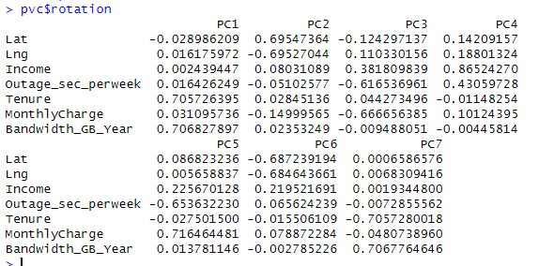
- Perform PCV
  - List of Quantitative Continuous Variables
Lat, Lng, Income, Outage_sec_perweek, Tenure, MonthlyCharge and Bandwidth_GB_Year
  - Which PCs should be retained and why?
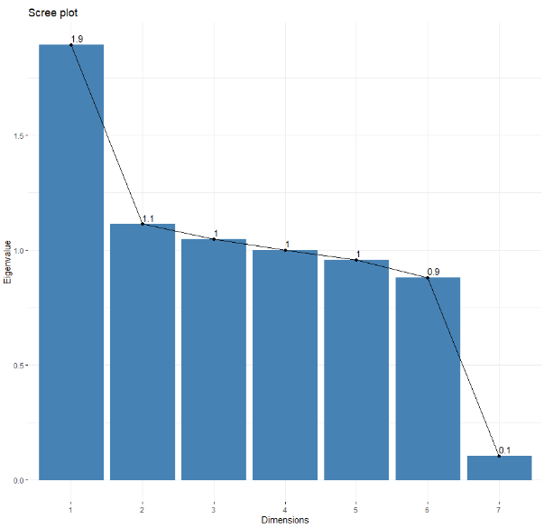
I would retain principal components (PCs) 1 through 5 because each of them have an eigenvalue that is equal to or greater than One. In principal component analysis, eigenvalues represent the amount of variance explained by each component. By keeping components that have an eigenvalue of One or higher, we can ensure that each component explains a substantial portion of the total variance in the data, making them meaningful for further analysis.
  - Benefit from the results of the PCA
An organization can benefit from the results of the PCA because noise from the data is reduced. It has identified patterns and relations between the columns. This can help with decision making. “PCA also allows us to visualize data and allow for the inspection of clustering” (Bigabid, n.d.). PCAs are versatile and are a useful tool to view at the start to gain a better understanding of the dataset.
- Panopto recording:
Mon May 06 2024 12:13:07 PM (panopto.com)
- Third-Party Code References
Bache, S. M., & Wickham, H. (2022). magrittr: A Forward-Pipe Operator for R. Retrieved from magrittr: https://magrittr.tidyverse.org, https://github.com/tidyverse/magrittr
Soetewey, A. (2020, 08 11). Outliers detection in R. Retrieved from Stats and R: https://statsandr.com/blog/outliers-detection-in-r/

- References
Bigabid. (n.d.). PCA: What, How, and Why. Retrieved from Bigabid: https://www.bigabid.com/what-is-pca-and-how-can-i-use-it/
Coll, J. (2020, May 7). Advantages And Pitfalls Of Using The Z Score. Retrieved from statcalculators: https://statcalculators.com/advantages-and-pitfalls-of-using-the-z-score/
Eric Straw, Ph.D. . (2023). Scales. Retrieved from Data Science Team SharePoint: https://westerngovernorsuniversity.sharepoint.com/sites/DataScienceTeam/Shared%20Documents/Forms/AllItems.aspx?id=%2Fsites%2FDataScienceTeam%2FShared%20Documents%2FGraduate%20Team%2FD206%2FStudent%20Facing%20Resources%2FDr%2E%20Straw%20breakdown%20of%20da
Sanford, C. (27, April 2024). What states have zip codes that start with 0? Retrieved from NCESC: https://www.ncesc.com/geographic-faq/what-states-have-zip-codes-that-start-with-0/#:~:text=Yes%2C%20there%20are%20several%20states%20in%20the%20US,%28VI%29%2C%20APO%20Europe%20%28AE%29%2C%20and%20FPO%20Europe%20%28AE%29.

Tables and Figures of Untreated Data D.1

Table 1
Str(churn)
Variable Name | Data Type | Description | Example
N/A | Qualitative/Categorical | This column does not have a name. It numbers the rolls. | 1, 2, 3, 4…
CaseOrder | Qualitative/Categorical | variable to hold the original order of the file | 1, 2, 3, 4…
Customer_id | Qualitative/Categorical | Distinct customer identifier | "K409198" "S120509" "K191035" "D90850" ...
Interaction | Qualitative/Categorical | IDs specific to customer transactions, registrations, and technical support interactions | "aa90260b-4141-4a24-8e36-b04ce1f4f77b" "fb76459f-c047-4a9d-8af9-e0f7d4ac2524" "344d114c-3736-4be5-98f7-c72c281e2d35”.
City | Qualitative/Categorical | City of residence provided on the billing statement for the customer | "Point Baker" "West Branch" "Yamhill" "Del Mar" ...
State | Qualitative/Categorical | State of residence provided on the billing statement for the customer | "AK" "MI" "OR" "CA" ...
County | Qualitative/Categorical | County of residence provided on the billing statement for the customer | "Prince of Wales-Hyder" "Ogemaw" "Yamhill" "San Diego" ...
Zip | Qualitative/Categorical | Zip of residence provided on the billing statement for the customer | 99927 48661 97148 92014 77461 31030 37847 73109 34771 45237 ...
Lat | Qualitative/Categorical | GPS coordinates of residence provided on the billing statement for the customer | 56.3 44.3 45.4 33 29.4 ...
Lng | Qualitative/Categorical | GPS coordinates of residence provided on the billing statement for the customer | -133.4 -84.2 -123.2 -117.2 -95.8 ...
Population | Quantitative/Numerical | The population residing within a one-mile radius of the customer, derived from census data | 38 10446 3735 13863 11352 17701 2535 23144 17351 20193 ...
Area | Qualitative/Categorical | The classification of area type (rural, urban, suburban) determined from census data | "Urban" "Urban" "Urban" "Suburban" ...
Timezone | Qualitative/Categorical | The time zone corresponding to the customer's residence, sourced from their sign-up information | "America/Sitka" "America/Detroit" "America/Los_Angeles" "America/Los_Angeles" ...
Job | Qualitative/Categorical | The occupation held by the customer (or invoiced individual) as disclosed in their sign-up details. | "Environmental health practitioner" "Programmer, multimedia" "Chief Financial Officer" "Solicitor" ...
Children | Quantitative/Numerical | The count of children within the customer's household, provided in their sign-up information. | NA 1 4 1 0 3 0 2 2 NA ...
Age | Quantitative/Numerical | The age of the customer | 68 27 50 48 83 83 NA NA 49 86 ...
Education | Qualitative/Categorical | The highest level of education achieved by the customer, as reported during sign-up | "Master's Degree" "Regular High School Diploma" "Regular High School Diploma" "Doctorate Degree" ...
Employment | Qualitative/Categorical | The current employment status of the customer, recorded during sign-up. | "Part Time" "Retired" "Student" "Retired" ...
Income | Quantitative/Numerical | The yearly income of the customer, reported at the time of sign-up. | 28562 21705 NA 18925 40074 ...
Marital | Qualitative/Categorical | The marital status of the customer as indicated in their sign-up information. | "Widowed" "Married" "Widowed" "Married" ...
Gender | Qualitative/Categorical | The self-identified gender of the customer, categorized as male, female, or nonbinary, based on sign-up details. | "Male" "Female" "Female" "Male" ...
Churn | Qualitative/Categorical | Using Yes or No Indicates whether the customer terminated service in the past month | "No" "Yes" "No" "No" ...
Outage_sec_perweek | Quantitative/Numerical | Average weekly downtime in seconds experienced by the customer's neighborhood | 6.97 12.01 10.25 15.21 8.96 ...
Email | Quantitative/Numerical | Total number of emails sent to the customer within the last year this includes marketing and correspondence | 10 12 9 15 16 15 10 16 20 18 ...
Contacts | Quantitative/Numerical | The number of times customer has called technical support | 0 0 0 2 2 3 0 0 2 1
Yearly_equip_failure | Quantitative/Numerical | Number of equipment failures necessitating reset or replacement in the previous year | 1 1 1 0 1 1 1 0 3 0
Techie | Qualitative/Categorical | Using Yes or No Reflects whether the customer identifies as technically inclined, based on initial questionnaire responses | "No" "Yes" "Yes" "Yes"
Contract | Qualitative/Categorical | Specifies the duration of the customer's contract (month-to-month, one year, two years) | "One year" "Month-to-month" "Two Year" "Two Year"
Port_modem | Qualitative/Categorical | Indicates whether the customer possesses a portable modem (yes, no) | "Yes" "No" "Yes" "No"
Tablet | Qualitative/Categorical | Indicates ownership of a tablet device (yes, no) | "Yes" "No" "Yes" "No"
InternetService | Qualitative/Categorical | Identifies the customer's internet service provider (DSL, fiber optic, None) | "Fiber Optic" "Fiber Optic" "DSL" "DSL"
Phone | Qualitative/Categorical | Informs on if the customer has a phone service | "Yes" "No" "Yes" "No"
Multiple | Qualitative/Categorical | Tells you if the customer has more than one line | "Yes" "No" "Yes" "No"
OnlineSecurity | Qualitative/Categorical | Does the customer have online security | "Yes" "No" "Yes" "No"
OnlineBackup | Qualitative/Categorical | Does the customer have online backup | "Yes" "No" "Yes" "No"
DeviceProtection | Qualitative/Categorical | Does the customer have a protection plan for the devices | "Yes" "No" "Yes" "No"
TechSupport | Qualitative/Categorical | Does the customer have tech support added to their plan | "Yes" "No" "Yes" "No"
StreamingTV | Qualitative/Categorical | Does the customer stream tv | "Yes" "No" "Yes" "No"
StreamingMovies | Qualitative/Categorical | Does the customer stream movies | "Yes" "No" "Yes" "No" .
PaperlessBilling | Qualitative/Categorical | Does the customer have paperless billing | "Yes" "No" "Yes" "No"
PaymentMethod | Qualitative/Categorical | Payment method used by the customer | "Credit Card (automatic)" "Bank Transfer(automatic)" "Credit Card (automatic)" "Mailed Check"
Tenure | Quantitative/Numerical | Number of months the customer has had service | 6.8 1.16 15.75 17.09 1.67 ...
MonthlyCharge | Quantitative/Numerical | Customer’s monthly bill | 171 243 159 120 151 ...
Bandwidth_GB_Year | Quantitative/Numerical | Avg yearly use of data | 905 801 2055 2165 271 ...
Item1 | Qualitative/Categorical | The rated provided by customers on a scale of 1 to 8 for Timely response | 5 3 4 4 4 3 6 2 5 2 ...
Item2 | Qualitative/Categorical | The rated provided by customers on a scale of 1 to 8 for Timely fixes | 5 3 4 4 4 3 6 2 5 2 ...
Item3 | Qualitative/Categorical | The rated provided by customers on a scale of 1 to 8 for Timely replacements | 5 3 4 4 4 3 6 2 5 2 ...
Item4 | Qualitative/Categorical | The rated provided by customers on a scale of 1 to 8 for Reliability | 5 3 4 4 4 3 6 2 5 2 ...
Item5 | Qualitative/Categorical | The rated provided by customers on a scale of 1 to 8 for Options | 5 3 4 4 4 3 6 2 5 2 ...
Item6 | Qualitative/Categorical | The rated provided by customers on a scale of 1 to 8 for Respectful response | 5 3 4 4 4 3 6 2 5 2 ...
Item7 | Qualitative/Categorical | The rated provided by customers on a scale of 1 to 8 for Courteous exchange | 5 3 4 4 4 3 6 2 5 2 ...
Item8 | Qualitative/Categorical | The rated provided by customers on a scale of 1 to 8 for Evidence of active listening | 5 3 4 4 4 3 6 2 5 2 ...
Note: Table 1 contains all the Variables, the type of Data, the description of the content and examples of the values.

Table 2
Column | Tenure | Children | Income | Techie | Age | Phone | Bandwidth_GB_Year | Total
Missing Count | 931 | 2495 | 2490 | 2477 | 2475 | 1026 | 1021 | 13906

Table 3
Column | Tenure |  | Children | Income | Techie | Age | Phone | Bandwidth_GB_Year | Total
Missing percentage |  | 9.31% | 24.95% | 24.90% | 24.77% | 24.75% | 10.26% | 10.21% | 13906

Table 5
Column | Tenure | Children | Income | Techie | Age | Phone | Bandwidth_GB_Year | Total
Missing Count | 0 | 0 | 0 | 0 | 0 | 0 | 0 | 0

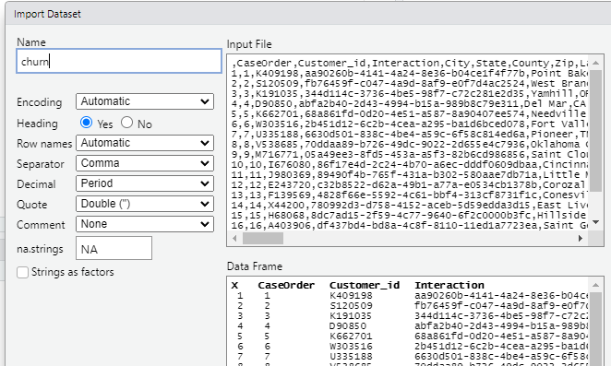
Figure: 1
Note: Importing the dataset

Figure: 2
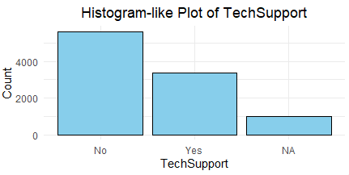
Note: Categorical bar plot of the TechSupport Column Mode

Figure: 3
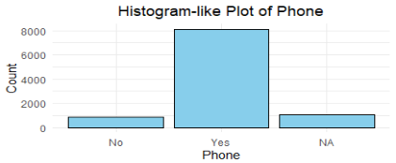
Note: Categorical bar plot of the Phone Column Mode

Figure: 4
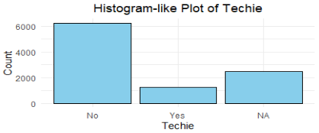
Note: Categorical bar plot of the Techie Column Mode

Figure: 5
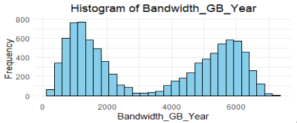
Note: Histogram of the Bandwidth_GB_Year column Mean

Figure: 6
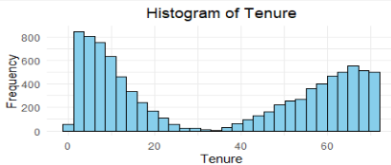
Note: Histogram of the Tenure Column Mean

Figure: 7
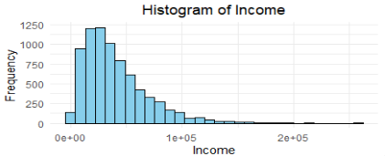
Note: Histogram of the Income Column Median

Figure: 8
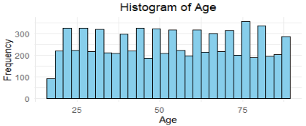
Note: Histogram of the Age Column Median

Figure: 9
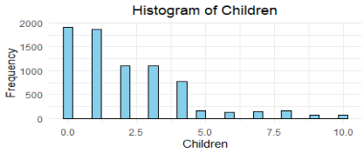
Note: Histogram of the Children Column Median

Figure: 10
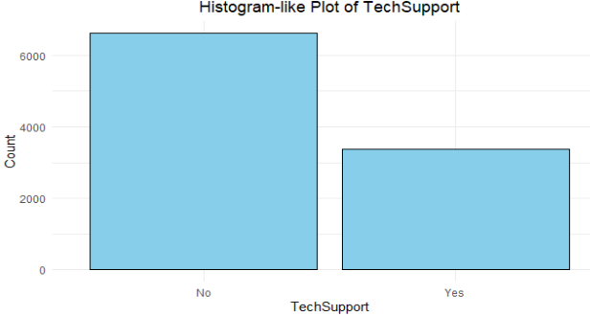
Note: Column: TechSupport

Figure: 11
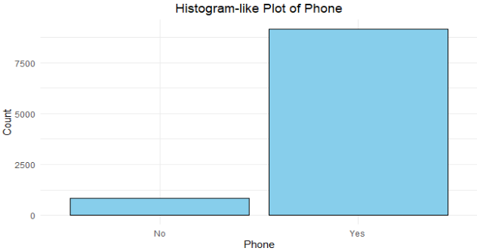
Note: Column: Phone

Figure: 12
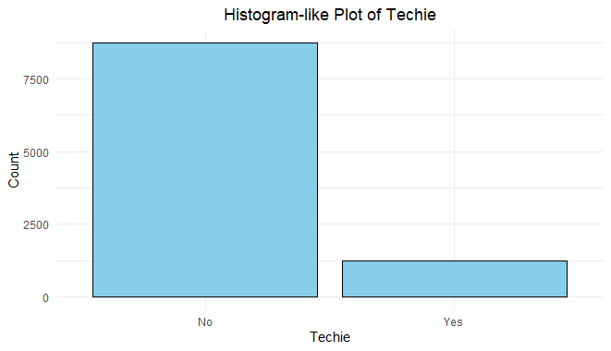
Note: Column: Techie

Figure: 13
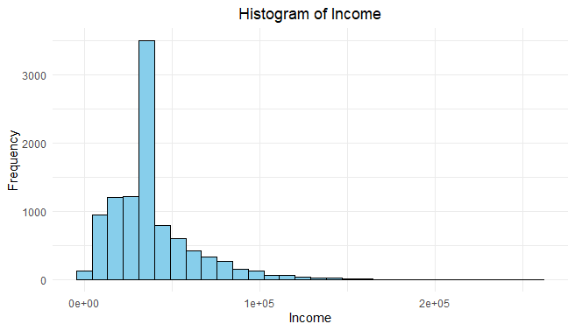
Note: Column: Income

Figure: 14
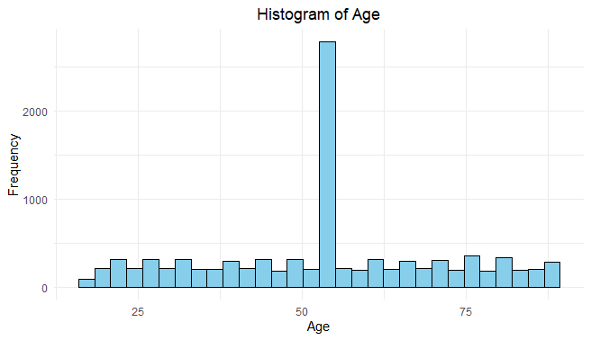
Note: Column: Age

Figure: 15
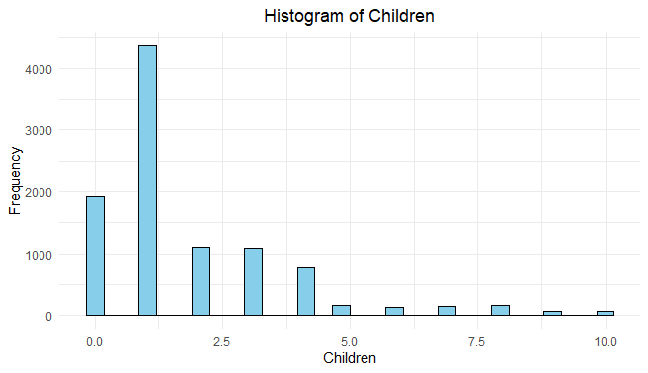
Note: column: Children

Figure: 16
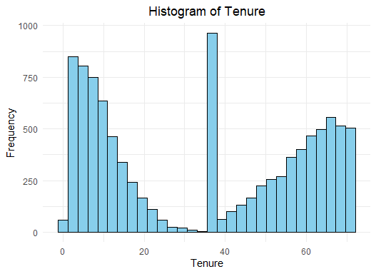
Note: Column: Tenure

Figure: 17
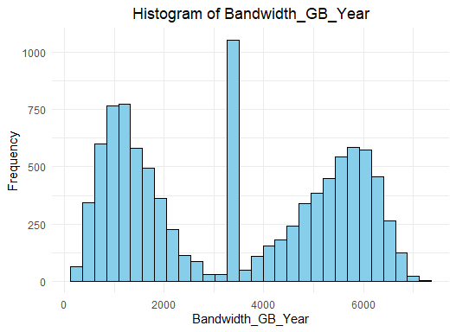
Note: Column: Bandwidth_GB_Year
Figure: 18

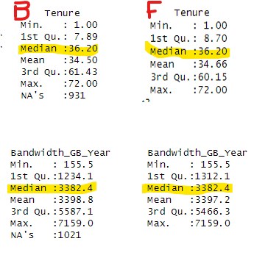

Figure: 19.
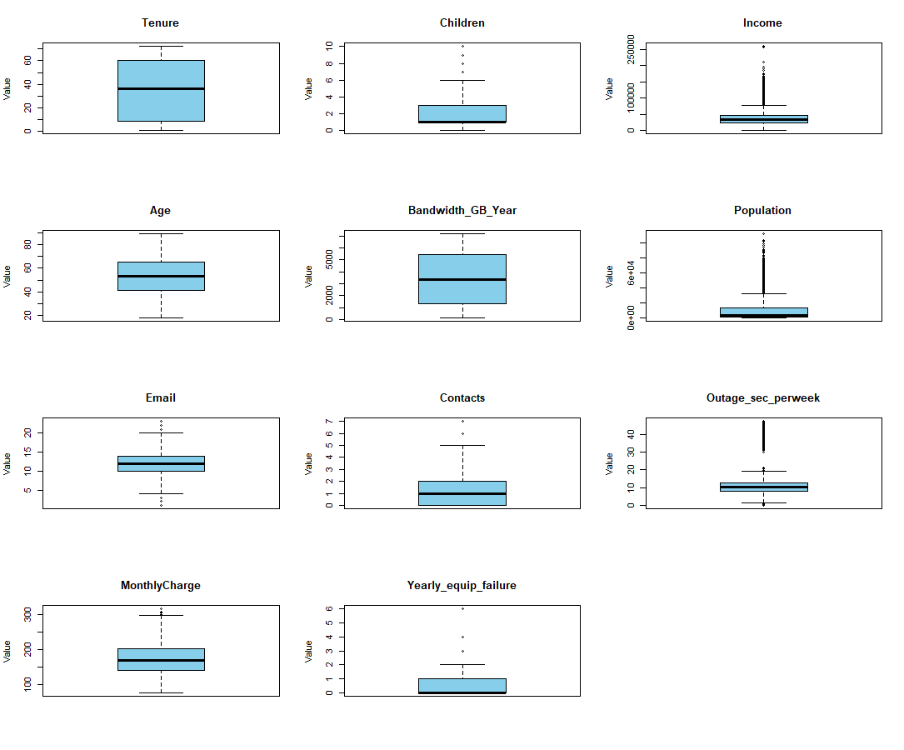

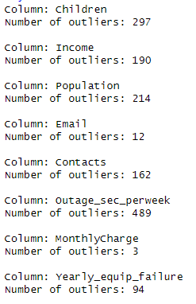
Figure 20

Figure 21
